|  |  |
| --- | --- |
|  | **DEPARTMENT OF COMPUTER SYSTEMS ENGINEERING**  **MEHRAN UNIVERSITY OF ENGINEERING & TECHNOLOGY, JAMSHORO**  **Database Management Systems (4th Semester) 18CS**  **Lab Experiment 1** |

|  |  |  |  |
| --- | --- | --- | --- |
| **Roll No:** |  | **Date of Conduct:** |  |
| **Submission Date:** |  | **Grade Obtained:** |  |

|  |  |  |  |
| --- | --- | --- | --- |
| **Problem Recognition (0.3)** | **Completeness & accuracy (0.4)** | **Timeliness (0.3)** | **Score (1.0)** |
|  |  |  |  |

**Objective: To create database in Ms. Access and to create relationships between tables in a database**.

**Tools: MicroSoft Access**

**Introduction:**

**MS ACCESS:** Microsoft Access is a Database Management System (DBMS) from Microsoft that combines the relational Microsoft Jet Database Engine with a graphical user interface and software development tools

* Microsoft Access is just one part of Microsoft’s overall data management product strategy.
* It stores data in its own format based on the Access Jet Database Engine.
* Like relational databases, Microsoft Access also allows you to link related information easily. For example, customer and order data. However, Access 2013 also complements other database products because it has several powerful connectivity features.

Microsoft Access stores information which is called a database. To use MS Access, you will need to follow these four steps −

* **Database Creation** − Create your Microsoft Access database and specify what kind of data you will be storing.
* **Data Input** −After your database is created, the data of every business day can be entered into the Access database.
* **Query** −This is a fancy term to basically describe the process of retrieving information from the database.
* **Report** (optional) − Information from the database is organized in a nice presentation that can be printed in an Access Report.

## Why Create Table Relationships?

MS Access uses table relationships to join tables when you need to use them in a database object. There are several reasons why you should create table relationships before you create other database objects, such as forms, queries, macros, and reports.

* To work with records from more than one table, you often must create a query that joins the tables.
* The query works by matching the values in the primary key field of the first table with a foreign key field in the second table.
* When you design a database, you divide your information into tables, each of which has a primary key and then add foreign keys to related tables that reference those primary keys.
* These foreign **key-primary key pairings** form the basis for table relationships and multi-table queries.

**Example Relationships Database.**

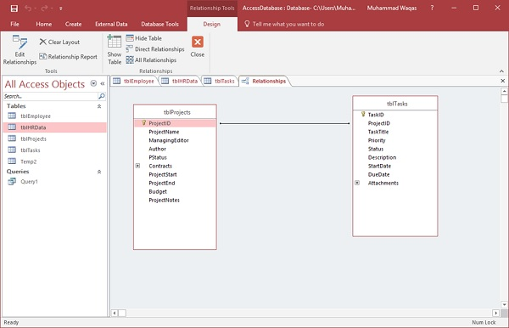

**Lab Task**

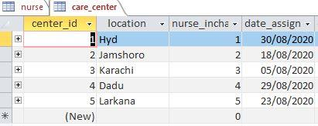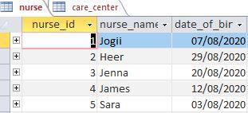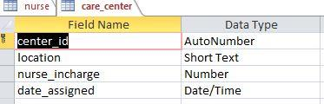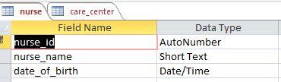**1. Create tables to show following one to one (1:1) relationship. Insert at least 5 records in each table. A nurse may be in-charge of a care center. A care center must have one nurse in-charge.**

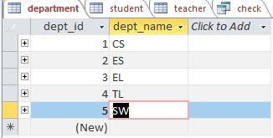2. **Create a database of University that consists of 03 tables (i.e. Student, Department, Teacher) and select appropriate primary key in each table.**

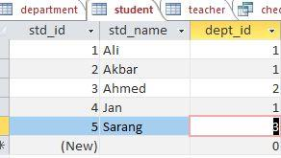

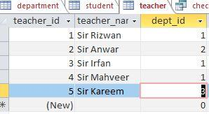

**3. Create relationship among the three tables.**

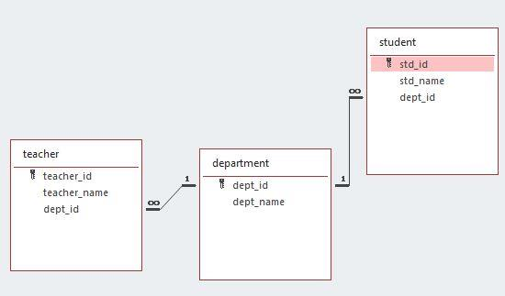

**4. Populate the tables with appropriate data.**

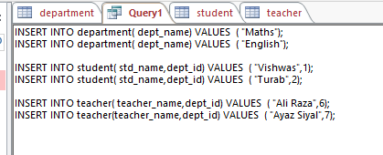

**5. Write down a query of TASK#02 database, in which user can find that which teacher is teaching students of Computer System Department.**

**Query:**



**Result of Query:**

